**Assisted Practice: 3.7 Delete an EBS Volume**

**Step 3.7.1:** Selecting the EBS volume you want to delete

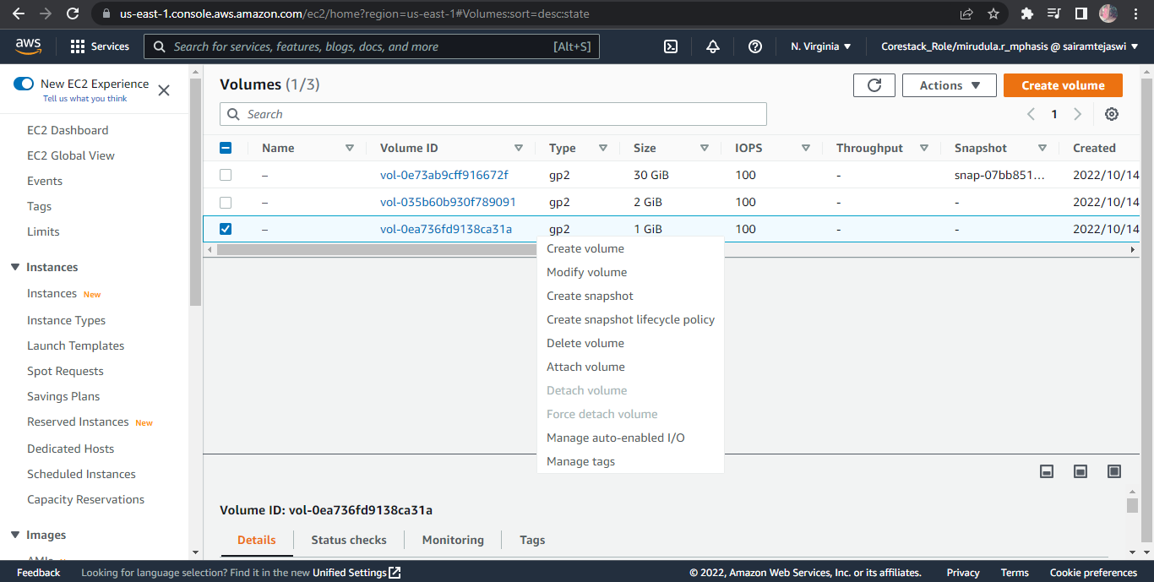

**Step 3.7.2:** Deleting the volume

